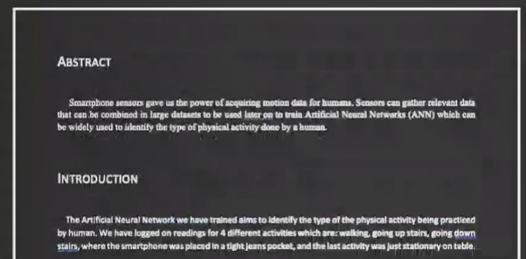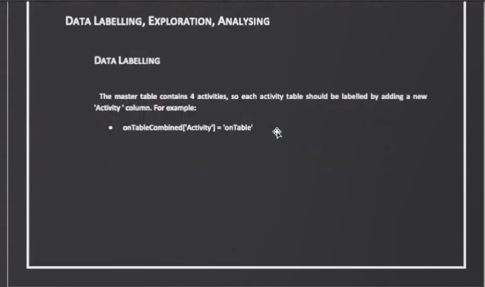

|  |  |  |  |
| --- | --- | --- | --- |
|  | | |



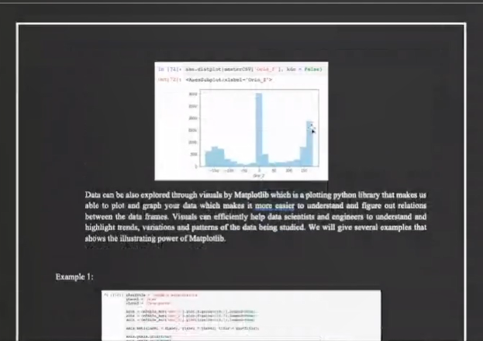\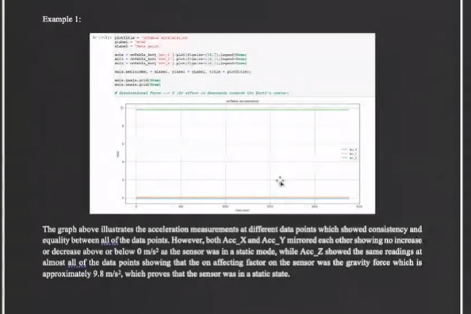

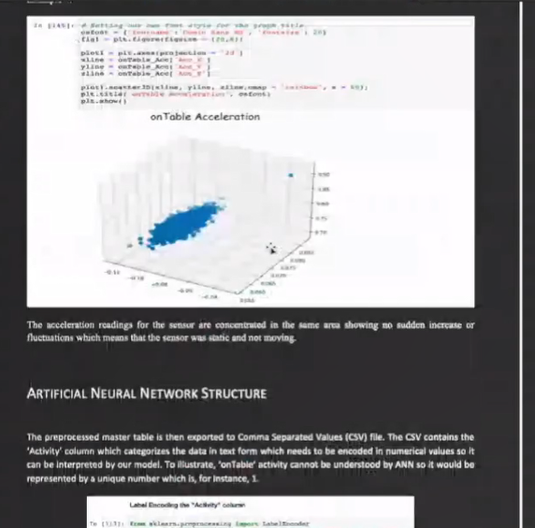

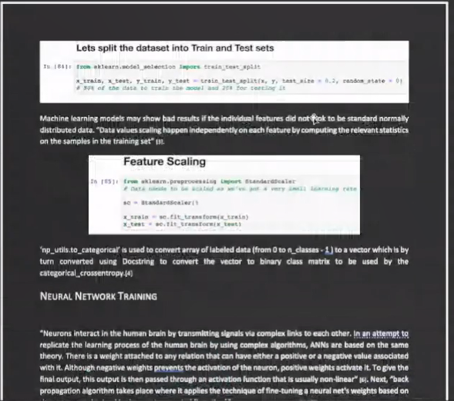

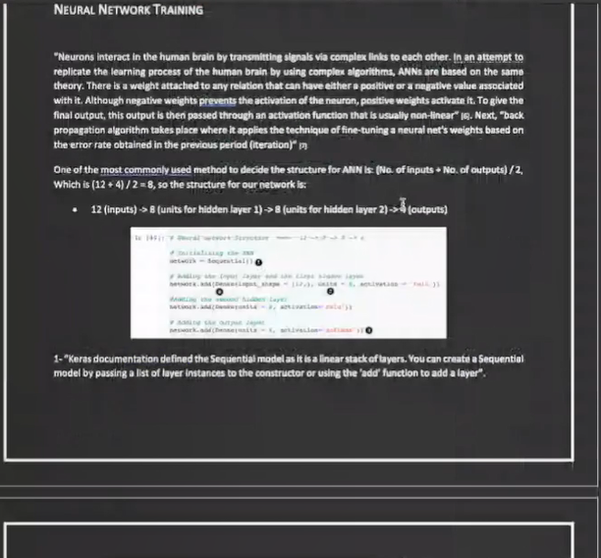

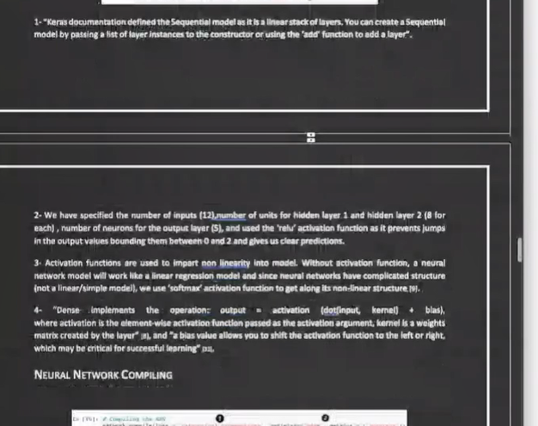

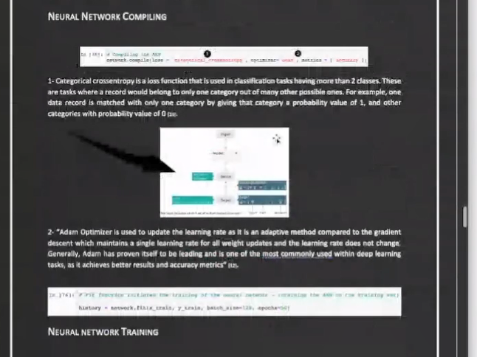

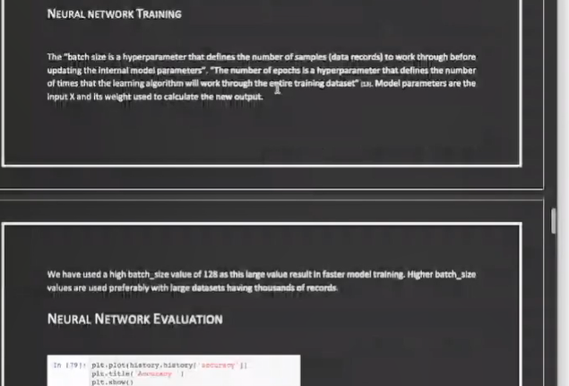

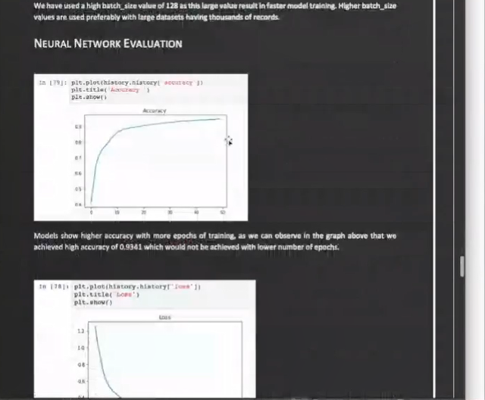

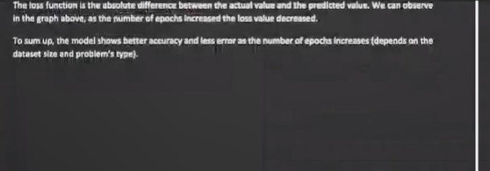

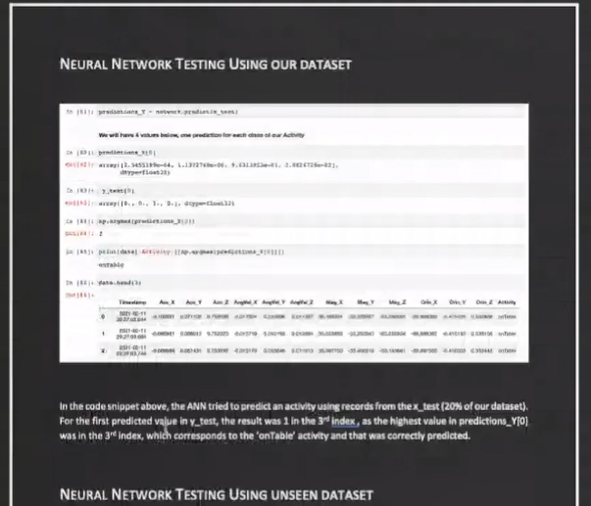

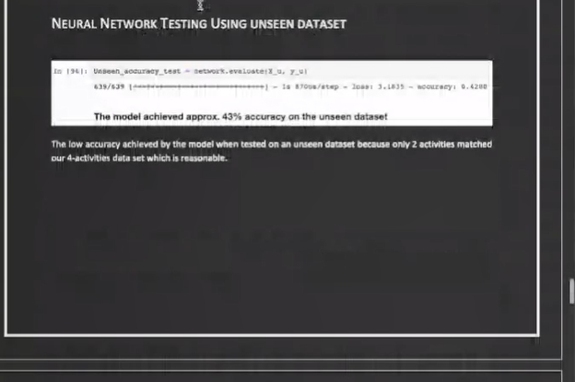

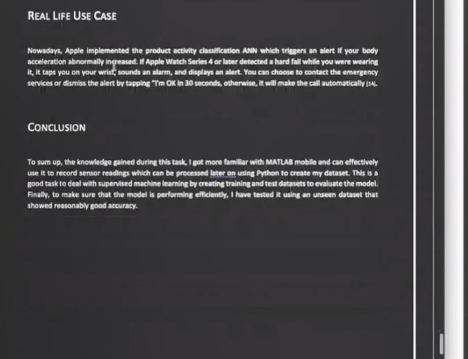

Hello,

I have got the following task:

The overall task is for you to build a neural network for activity classification which should be initially trained

and validated against Chatty-Dataset. You need to pick any four (4) of the following activities:

(1) walking, (2) running /jogging, (3) Jumping, (4) Cycling, (5) going up the stairs, (6) going downstairs, (7) drop

& pickup, (8) dancing, (9) shaking, (10) sitting, (11) lying down, (12) standing.

You are to give a report of: your entire experience in creating your dataset; model creation, hyperparameters and

model performance. It would be useful to first introduce the dataset and then carry out extensive data mining

activities like data cleaning, data transformation etc. The preferred language for data mining for this assignment

is Python.

You are also expected to use appropriate plots/ graphs and provide a short description (of your own

interpretation) of the results of each selected activity. Finally, you need to provide a concluding section reflecting

the knowledge gained from the results.

However I am not able to finish it on time.

Do you understand the requirements and are able to help me?

I will attach the data sets as well.